**2.1 Math:** Solve each problem. Show your work. Choose one of the problems and explain step by step how you solved it.

1. Byron owned a bakery. He baked 60 chocolate chip cookies. He sold 37 cookies. How many cookies did Byron have left?
2. Mason went hiking and collected 42 rocks for his rock collection. On his way home he dropped 13 rocks. How many rocks does Mason have now?

**2.2 Math:**

1. Find 2 examples of arrays in the real world. Draw a picture to represent each array, write the multiplication and repeated addition equation for each array.
2. Create an array for the following repeated addition sentence 3+3+3+3+3=__
3. Explain how arrays and repeated addition are related.

**3.1 Math:** Complete the In and Out boxes below**.**

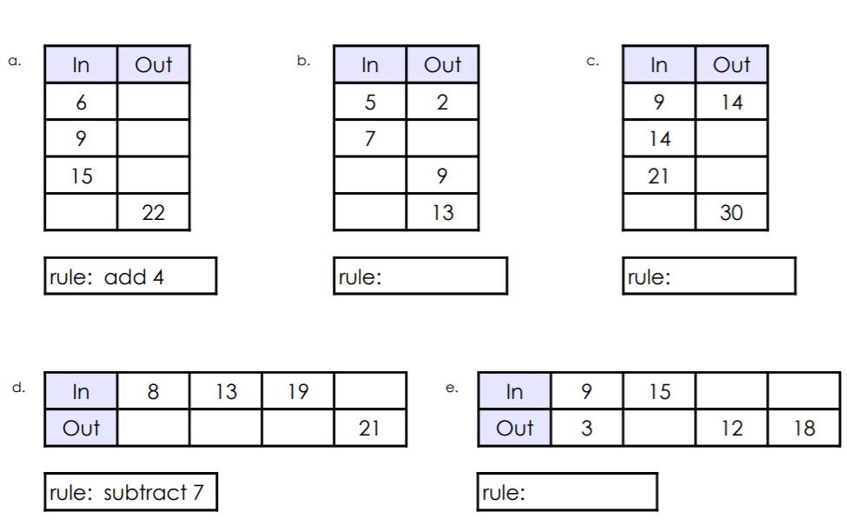

**Social Studies:**

Write a letter to a friend (use notebook paper or the graphic organizer on the back). In your letter, explain at least 2 ways your life is similar to the Creek or Cherokee and at least 2 ways your life is different from the Creek or Cherokee. **Don’t forget the 5 main parts of a friendly letter.