Homework Week of September 16, 2019
Complete the three assignments and turn them into your teacher by Friday. Complete only the math assignment that matches your math level. Please use lined paper and a PENCIL.
1) Social Studies,
Compare and Contrast Jimmy Carter and MLK Jr. using the Venn diagram on the back.
You should have three facts in each part.
2) 2.1 Math Group: Below are the types of books found in the library:
Types of Books | Number of Copies
Fairy Tales | 519
Non Fiction | 499
Biography | 435
Fiction | 294
Use the table above to answer the questions below.
1. Which type of book has more copies than Biography but less than Fairy Tales?
2. Put the numbers in order from least to greatest.
3. How many Fairy Tales and Non Fiction books are there altogether? (Draw base 10 blocks to help you solve.)
4. What number is < than 800 but > than 500?
2.2 Math Group: Create 5 three digit subtraction with regrouping equations and explain the steps for one of your problems.
Ex: 739 - 257 =
Explanation Example:
- First I used place value.
- Next, I subtracted the ones place. I subtracted 9-7 and got 2 ones.
- Next, I go to tens place and I see that I have a bigger number on the floor and I can’t subtract 3-5 tens, so I have to go the hundreds place and regroup one hundred for 10 tens. That leaves me with 6 hundreds and 13 tens.
- Now, I can subtract 13-5 tens because I have more on top. 13-5=8 tens
- Last, I look at the hundreds to subtract 6-2= 4 hundreds.
- Finally, I get the answer of 482 and check my work
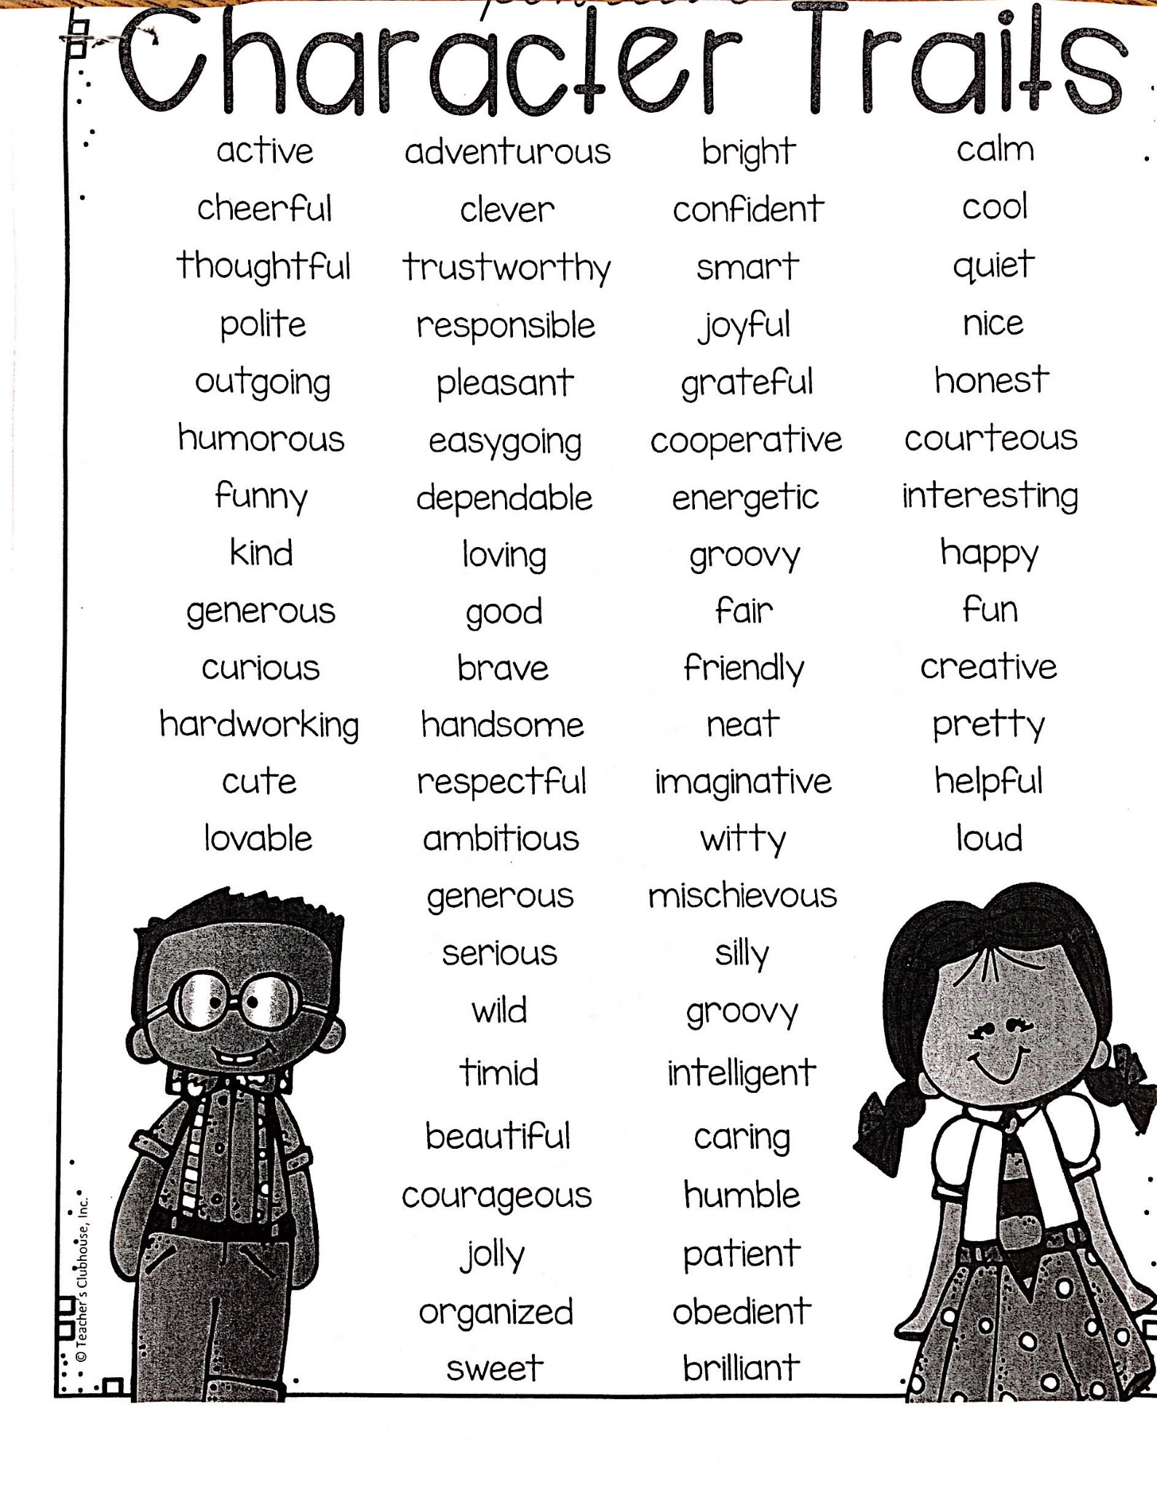
3.1 Math Group: Write and solve 1 addition and 1 subtraction story problem. Make sure you choose 3-digit numbers that will involve regrouping to solve. Use the CUBES (or ACE) strategy to solve and check your work.
3) canned wi

