Name _______________________
Homework Week of September 3, 2019
Complete the three assignments and turn them into your teacher by Friday. Your work should be written in pencil and on lined paper. Complete only the math assignment that matches your math level.

1.) 2.1 Math Group: Pick three numbers that are at least 3 digits each. Write or draw the number in at least three different ways (standard form, expanded form, base 10 blocks, or word form).
2.2 Math Group: The table below lists the number of acorns Sarah found in her backyard each day. On which 3 days did Sarah find a total of 166 acorns?
Find the sum of the 3 numbers. (Use strategies like decomposing, number line, base ten blocks, look at the ones place to help you solve.)
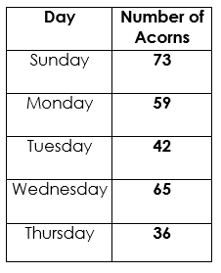
3.1 Math Group: Janine owns a catering service company. She was hired to cater for the mayor’s 50th birthday.
For the appetizers, she needs to make 750 mini meat pies. She divided her crew into 3 teams. If the first team made 235, and the second made 275, how many pies should the third team make?

2.) Jackie Robinson Interview: Pretend you are going to interview Jackie Robinson. Write 5 questions you would ask him (not a question you already know the answer to).

3.) Reading: Read a book of your choice for 20 minutes.

